Network Troubleshooting, Management, Monitoring, and Optimization
Q1. Use the Windows command prompt to run the command ipconfig /all on your computer and take a screenshot of the output. Identify and write down your IPv4 address, subnet mask, default gateway, and DNS servers as shown in the result.
Ans:
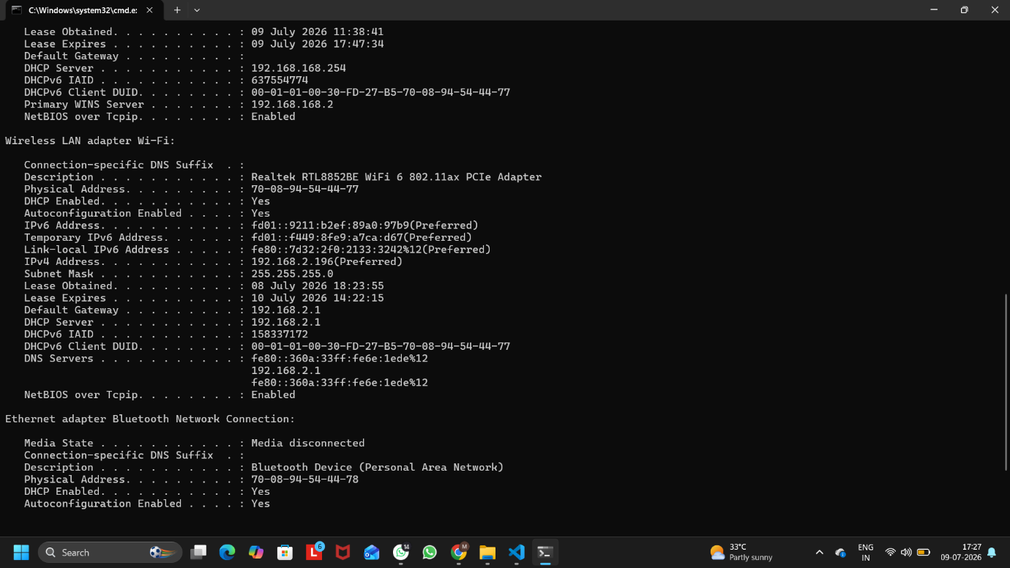
Figure 1: Output of the ipconfig /all Command
Network Configuration:
- IPv4 Address: 192.168.2.196
- Subnet Mask: 255.255.255.0
- Default Gateway: 192.168.2.1
- DNS Server(s):
  - fe80::360a:33ff:fe6e:1ede%12
  - 192.168.2.1

Q2. Simulate a network connectivity issue by disconnecting your Wi-Fi or Ethernet cable, then use the ping command to check connectivity to www.google.com. Reconnect and repeat the ping. Write a short note on the difference in results and what each status means.
Ans:
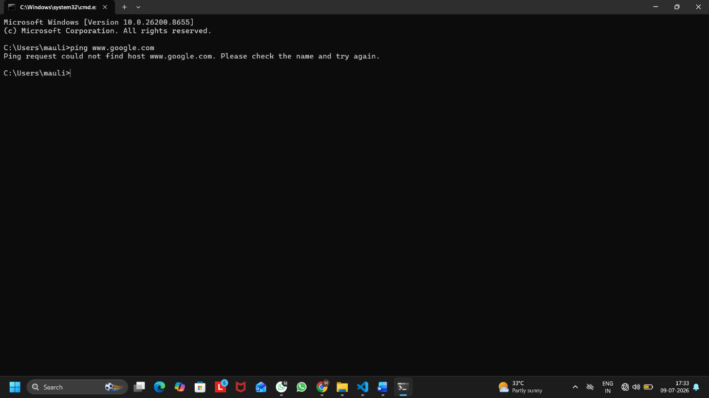
Figure 1: Ping Result with Internet Disconnected

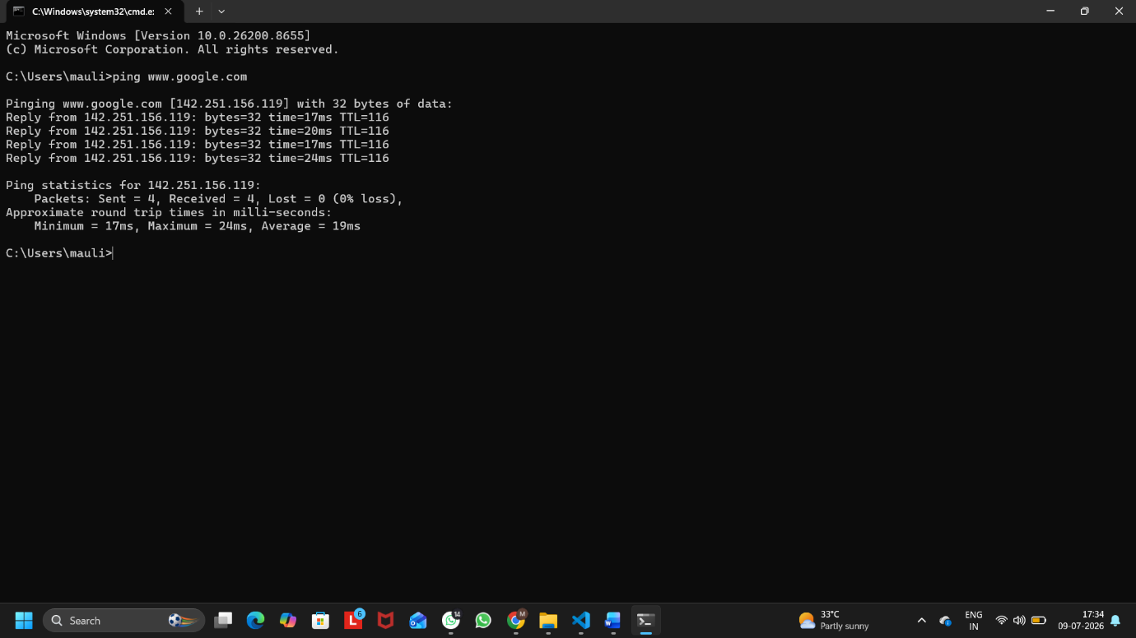
Figure 2: Ping Result with Internet Connected
Observation
Before Reconnecting (Internet Disconnected):
- The ping command failed and no reply was received from Google.
- This happened because the computer was not connected to the internet.

After Reconnecting (Internet Connected):
- The ping command successfully received replies from Google.
- This indicates that the internet connection was restored and the network is working properly.

Difference in Results:
Internet Disconnected | Internet Connected
No response from Google. | Reply received from Google.
Connection failed. | Connection successful.
Network or internet unavailable. | Network and internet working properly.

What Each Status Means:
1. Ping request could not find host www.google.com
- This status indicates that the computer could not resolve the website name.
- It usually occurs when the internet connection is unavailable or DNS services are not working properly.
2. Reply from 142.251.156.119
- This status indicates that the destination server (Google) is reachable.
- The network connection is working properly and data packets are successfully sent and received.
3. Time = 17ms, 20ms, etc.
- It shows the time taken for a packet to travel to the destination and return.
- Lower values indicate better network performance.
4. TTL = 116
- TTL (Time To Live) indicates the maximum number of network hops a packet can travel before being discarded.
- It helps prevent packets from circulating indefinitely in the network.
5. Lost = 0 (0% loss)
- This indicates that no packets were lost during transmission.
- A 0% packet loss means the network connection is stable and reliable.

Q3. Open Task Manager or Resource Monitor on your system and monitor network usage for 5 minutes while streaming a YouTube video. Record the peak network usage value and note which process used the most bandwidth during this time.
Ans:
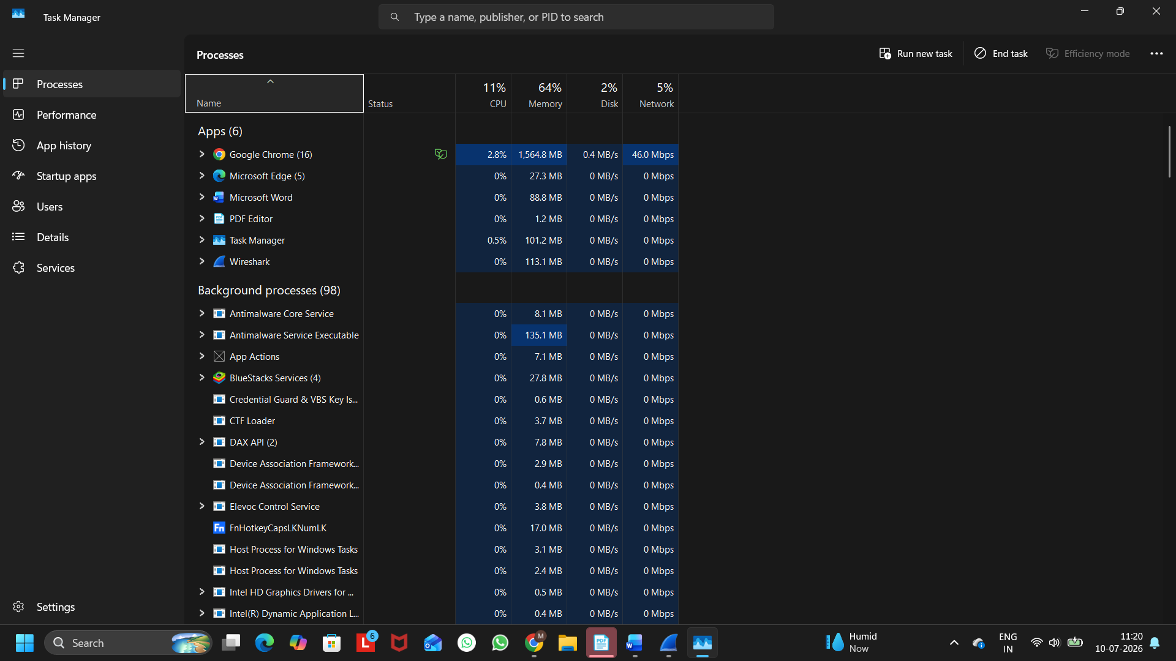
Figure 1: Network Usage Monitored in Task Manager While Streaming a YouTube Video

Peak Network Usage: 46.0 Mbps
Process Using the Most Bandwidth: Google Chrome (chrome.exe)

Observation:
I monitored the network usage for 5 minutes while streaming a YouTube video using Google Chrome. The highest network usage recorded was 46.0 Mbps. During this time, Google Chrome used the most bandwidth because it was streaming video content over the internet.

Q4. Download and install Wireshark (or use an online packet capture demo if installation is not possible). Capture at least 30 seconds of network traffic while browsing Flipkart or Instagram Web, then filter the packets to show only HTTP or HTTPS traffic. List 3 types of information you can see in these filtered packets.<br><br><em><strong>Hint:</strong> Use the filter bar in Wireshark and try http or https as the filter keyword.</em>
Ans:
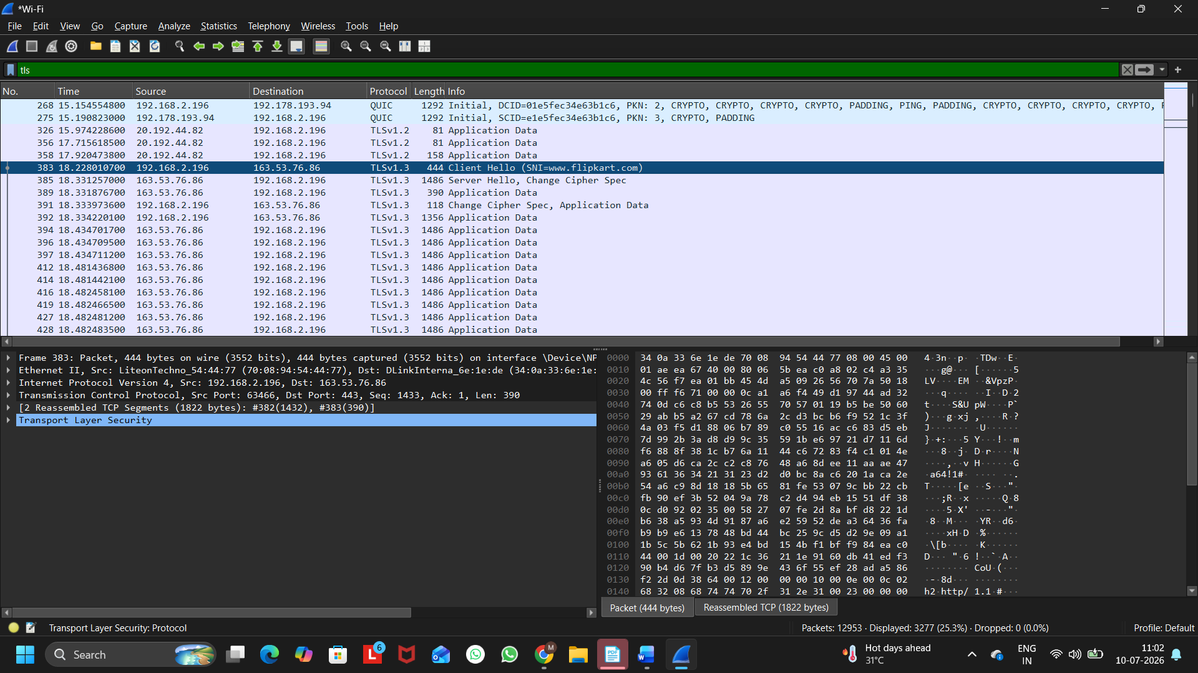
Figure 1: HTTPS (TLS) Traffic Captured Using Wireshark While Browsing Flipkart

Three Types of Information Visible in the Filtered Packets:
- Source IP Address
  - Shows the IP address of the sender (e.g., 192.168.2.196).
- Destination IP Address
  - Shows the IP address of the destination server (e.g., 163.53.76.86).
- Protocol
  - Shows the protocol being used for secure communication, such as TLSv1.3 (HTTPS).

Q5. Imagine your friend is complaining about slow internet while gaming online. Use ChatGPT or any AI tool to generate a troubleshooting checklist (at least 5 points) for optimizing home network speed and reliability. Paste the AI's response and highlight one suggestion you would try first.
Ans:
AI-Generated Troubleshooting Checklist for Slow Internet While Gaming:
- Restart the modem and router to refresh the internet connection.
- Use a wired Ethernet connection instead of Wi-Fi for a more stable and faster connection.
- Close unnecessary apps and downloads that may be using internet bandwidth.
- Place the Wi-Fi router in a central location to improve signal strength and reduce interference.
- Update the router firmware and network drivers to ensure better performance and security.
Suggestion I Would Try First:
I would first restart the modem and router because it is a simple and quick solution that often resolves temporary network issues and improves internet performance.

